ATLAS™
CONTRACT ADMINISTRATOR
PROFESSIONAL TOOLKIT
The 6 Essential Toolkits for Better Construction Contract Administration

THE SIX DISCIPLINES 1 KNOW THE CONTRACT • 2 PROTECT YOUR RIGHTS • 3 CONTROL THE CHANGE • 4 PROTECT THE TIME • 5 PROTECT THE MONEY • 6 PROTECT THE EVIDENCE

Implementation Edition

How to Use This Pack
This pack is designed to be implemented on live construction projects. Each toolkit combines a visual workflow, decision/checklist tools, editable forms and registers, and an implementation routine. The tools are contract-form neutral: users must insert the actual clause references, notice periods, terminology and procedures from the signed contract and applicable law.
1. Mobilise the six core registers at project commencement.
2. Assign a named owner for each register and template family.
3. Review deadlines, change, delay and claims in a standing weekly contract administration meeting.
4. Cross-reference issues between the notice, variation, delay, payment and evidence tools using a common issue reference.
5. Archive closed matters and record lessons learned at project close-out.
ATLAS™ TOOLKIT 1
KNOW THE CONTRACT
Contract Interpretation & Clause Navigation
Build a one-page operating map of the contract so that the project team can identify obligations, procedures, deadlines and consequences quickly.

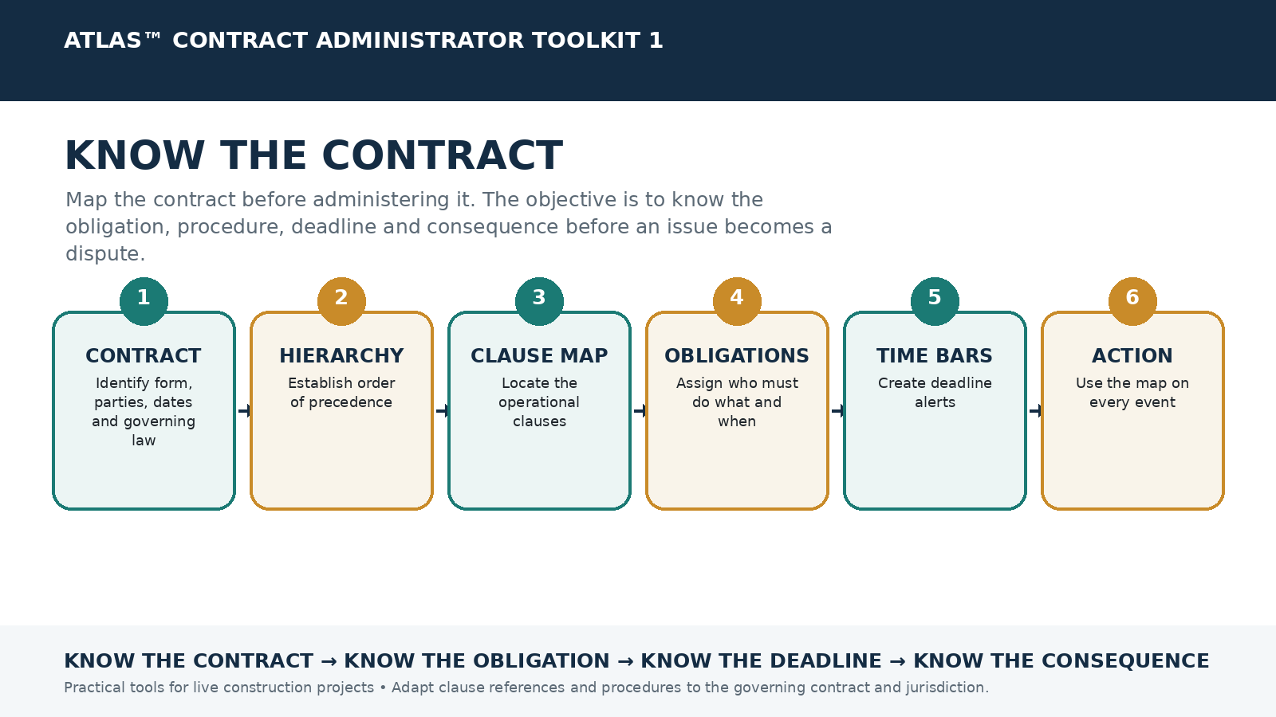

Use & Adaptation Note
This toolkit is a practical contract administration aid. It is intentionally contract-form neutral. Before use, adapt clause references, notice periods, service requirements, terminology, statutory requirements and dispute procedures to the signed contract, its amendments and the governing law. It does not replace project-specific legal advice where legal advice is required.

1. Contract Particulars Sheet
Project
Employer
Contractor
Contract Administrator / Engineer
Contract Form & Edition
Contract Date
Contract Sum
Commencement Date
Time for Completion / Completion Date
Defects / DLP Period
Governing Law
Dispute Mechanism
Seat / Venue
Liquidated Damages / Delay Damages
Retention
Performance Security
Advance Payment
Key Insurance Requirements

2. Contract Document Hierarchy / Order of Precedence
Contract Document | Date / Revision | Order of Precedence | Stored Location | Reviewed By

3. Key Clause Map
Subject | Clause | Key Procedure | Deadline / Period | Responsible Person

4. Contractual Obligation Matrix
Party | Obligation | Trigger | Deadline | Required Action / Output | Consequence of Failure

5. Time-Bar & Deadline Alert Register
Event / Obligation | Clause | Trigger Date | Notice Due | Claim / Detail Due | Owner | Status

6. Contract Review Checklist
☐ Signed agreement and amendments located
☐ Particular / Special Conditions reviewed against General Conditions
☐ Definitions relevant to administration highlighted
☐ Document precedence confirmed
☐ Notice method and addresses confirmed
☐ Time bars and condition precedents extracted
☐ Payment procedure and certification dates mapped
☐ Variation procedure mapped
☐ Delay / EOT procedure mapped
☐ Suspension and termination procedures mapped
☐ Security, insurance and retention requirements recorded
☐ Dispute escalation mechanism mapped
GOLDEN RULE Never read a clause in isolation. Check the definition, related clauses, Particular Conditions / amendments, governing law and the consequence of non-compliance.

Implementation on a Live Project
1. Complete the Contract Particulars Sheet before the first administration meeting.
2. Build the Clause Map from the signed contract, not from a standard unamended form.
3. Load every time bar and recurring deadline into the Deadline Register.
4. Review the Obligation Matrix with commercial, planning and project leadership.
5. Keep the Clause Map available in weekly project meetings and update it when amendments or supplemental agreements are issued.

Minimum Ownership
Role | Responsibility
Contract Manager / Lead CA | Own the contract map and legal/contractual interpretation workflow.
Project Manager | Ensure operational teams understand major obligations and triggers.
Planner | Integrate contractual time requirements and programme obligations.
Commercial / QS | Map payment, valuation, claims and final account provisions.
IMPLEMENTATION PRINCIPLE A toolkit only adds value when someone owns it, deadlines are reviewed routinely, and project teams actually use the outputs in meetings and decisions.

ATLAS™ TOOLKIT 2
PROTECT YOUR RIGHTS
Notices, Correspondence & Communication
Preserve contractual rights by making notices timely, valid, factual, traceable and connected to the relevant clause and event.

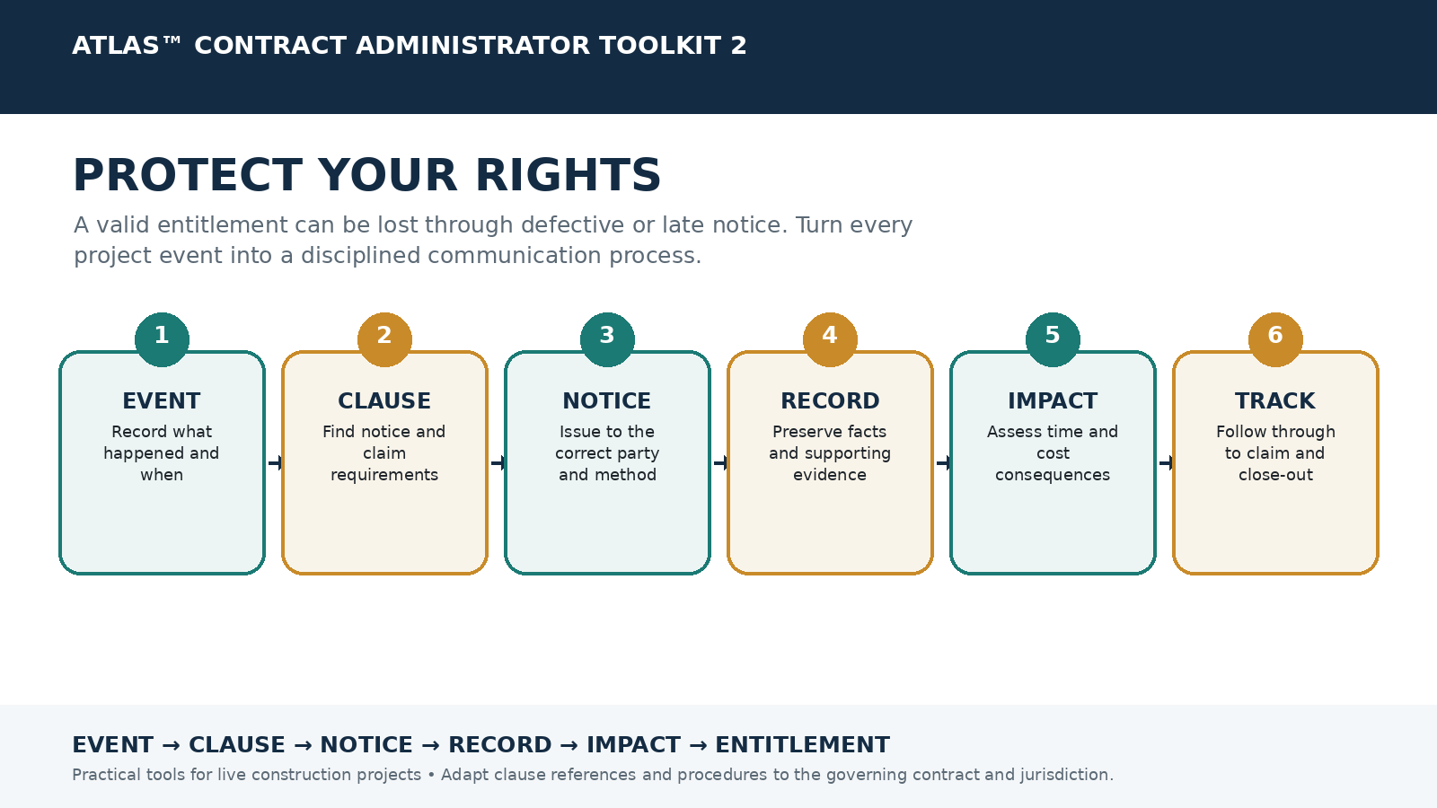

Use & Adaptation Note
This toolkit is a practical contract administration aid. It is intentionally contract-form neutral. Before use, adapt clause references, notice periods, service requirements, terminology, statutory requirements and dispute procedures to the signed contract, its amendments and the governing law. It does not replace project-specific legal advice where legal advice is required.

1. The 6-Point Notice Validity Test
☐ WHO must issue the notice?
☐ TO WHOM must it be sent?
☐ WHAT event / contractual matter is being notified?
☐ WHEN must it be issued?
☐ HOW must it be served?
☐ WHERE / to which contractual address or platform must it be sent?

2. Master Notice Register
Ref | Event | Clause | Event Date | Notice Due | Notice Issued | Method / Recipient | Follow-up Due | Status

3. Master Contractual Notice Template
Project
Contract
Date
Notice / Letter No.
To
From

Subject: NOTICE OF [EVENT / MATTER]
We refer to [instruction / event / circumstance] occurring on [date].
The [Contractor / Employer / Party] hereby gives notice pursuant to Clause [X] that [concise factual description of the event].
The event has caused and/or is likely to cause an effect upon [time / cost / sequence / productivity / access / resources]. The full consequences are continuing to be assessed.
The [Contractor / Employer / Party] reserves all contractual and legal rights arising from this matter, including any entitlement to additional time and/or payment where applicable.
Further particulars and supporting records will be provided in accordance with the Contract. Please acknowledge receipt.
DRAFTING CONTROL Replace all bracketed fields. Verify the clause, notice period, addressee and permitted service method before issue.

4. Notice of Delay
Project
Contract
Date
Notice / Letter No.
To
From

Subject: NOTICE OF DELAY / DELAY EVENT
We refer to [event / instruction / certificate] dated [date].
The event is affecting or is likely to affect Activity [ID / description] and may affect the Time for Completion. Contemporaneous records and programme impact are being maintained.
This correspondence is issued without prejudice to any other entitlement or remedy available under the Contract and applicable law.
DRAFTING CONTROL Replace all bracketed fields. Verify the clause, notice period, addressee and permitted service method before issue.

5. Notice of Variation / Change
Project
Contract
Date
Notice / Letter No.
To
From

Subject: NOTICE OF VARIATION / CHANGE
We refer to [event / instruction / certificate] dated [date].
We consider the instruction / revised information to constitute or potentially constitute a change to the contractual scope. The resulting time and cost consequences are being assessed.
This correspondence is issued without prejudice to any other entitlement or remedy available under the Contract and applicable law.
DRAFTING CONTROL Replace all bracketed fields. Verify the clause, notice period, addressee and permitted service method before issue.

6. Notice of Claim
Project
Contract
Date
Notice / Letter No.
To
From

Subject: NOTICE OF CLAIM
We refer to [event / instruction / certificate] dated [date].
This notice is issued to preserve entitlement arising from [event]. The contractual and factual basis, impact and quantum will be particularised in accordance with the Contract.
This correspondence is issued without prejudice to any other entitlement or remedy available under the Contract and applicable law.
DRAFTING CONTROL Replace all bracketed fields. Verify the clause, notice period, addressee and permitted service method before issue.

7. Notice of Late Information / RFI Impact
Project
Contract
Date
Notice / Letter No.
To
From

Subject: NOTICE OF LATE / OUTSTANDING INFORMATION
We refer to [event / instruction / certificate] dated [date].
The information identified above is required by [required date] to avoid impact to [activity / procurement / workfront]. Please provide the required information / instruction.
This correspondence is issued without prejudice to any other entitlement or remedy available under the Contract and applicable law.
DRAFTING CONTROL Replace all bracketed fields. Verify the clause, notice period, addressee and permitted service method before issue.

8. Reservation of Rights
Project
Contract
Date
Notice / Letter No.
To
From

Subject: RESERVATION OF RIGHTS
We refer to [event / instruction / certificate] dated [date].
Nothing in ongoing performance, discussions, mitigation measures or interim arrangements is intended to waive any contractual or legal right. All rights are expressly reserved.
This correspondence is issued without prejudice to any other entitlement or remedy available under the Contract and applicable law.
DRAFTING CONTROL Replace all bracketed fields. Verify the clause, notice period, addressee and permitted service method before issue.

9. Notice of Non-Payment
Project
Contract
Date
Notice / Letter No.
To
From

Subject: NOTICE OF NON-PAYMENT / OVERDUE PAYMENT
We refer to [event / instruction / certificate] dated [date].
Payment due under [certificate / application / clause] remains outstanding. Please arrange payment and confirm the remittance position in accordance with the Contract.
This correspondence is issued without prejudice to any other entitlement or remedy available under the Contract and applicable law.
DRAFTING CONTROL Replace all bracketed fields. Verify the clause, notice period, addressee and permitted service method before issue.

10. Correspondence Quality Control
☐ Use facts, dates and document references
☐ State the required action clearly
☐ Identify the clause where appropriate
☐ Avoid unnecessary admissions or emotive language
☐ Attach supporting documents or identify where they are stored
☐ State a response date where needed
☐ Preserve rights where the full impact is not yet known
☐ Confirm service in the contractually permitted manner
☐ Enter the issue in the Notice Register
GOLDEN WORKFLOW EVENT → CLAUSE → NOTICE → RECORD → IMPACT → ENTITLEMENT → CLAIM / RESPONSE → CLOSE-OUT

Implementation on a Live Project
1. Create the Master Notice Register on Day 1.
2. Pre-address the approved notice templates with contractual addresses and service methods.
3. Review notice deadlines at least weekly and during every major event meeting.
4. Require verbal instructions with contractual significance to be confirmed in writing.
5. Link every notice to an evidence folder and to the associated change, delay or claim register.

Minimum Ownership
Role | Responsibility
Contract Administrator | Draft, validate, issue and log notices.
Project Manager | Escalate operational events promptly.
Planner / Commercial | Provide time and cost implications for follow-up particulars.
Document Controller | Maintain proof of issue, receipt and filing.
IMPLEMENTATION PRINCIPLE A toolkit only adds value when someone owns it, deadlines are reviewed routinely, and project teams actually use the outputs in meetings and decisions.

ATLAS™ TOOLKIT 3
CONTROL THE CHANGE
Variation & Change Management
Make project change visible, authorised, measured, valued and closed so that additional scope does not become unrecoverable work.

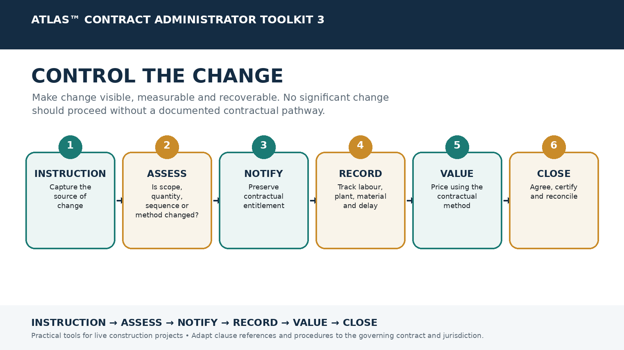

Use & Adaptation Note
This toolkit is a practical contract administration aid. It is intentionally contract-form neutral. Before use, adapt clause references, notice periods, service requirements, terminology, statutory requirements and dispute procedures to the signed contract, its amendments and the governing law. It does not replace project-specific legal advice where legal advice is required.

1. Variation Identification Test
☐ Has scope changed?
☐ Has quantity changed?
☐ Has quality / specification changed?
☐ Has sequence changed?
☐ Has method or access changed?
☐ Have working hours or constraints changed?
☐ Has additional testing or coordination been required?
☐ Has a drawing / instruction created extra work?
☐ Has an omission affected remaining work?
☐ Has acceleration or resequencing been requested?

2. Change Control Initiation Form
Change Ref
Date Identified
Source / Instruction Ref
Originator
Description of Original Requirement
Description of Changed Requirement
Contract Clause / Basis
Notice Required?
Time Impact Potential
Cost Impact Potential
Authorisation Status
Responsible Owner

3. Variation / Change Register
VO / Change No. | Description | Instruction Date | Notice Date | Quotation | Submitted Value | Approved Value | Time Impact | Status

4. Variation Pricing Sheet
Cost Component | Basis / Quantity | Rate | Amount | Supporting Record

- Labour
- Materials
- Plant / equipment
- Subcontractors
- Preliminaries / time-related cost
- Attendance
- Overheads
- Profit
- Design / testing
- Other contractual adjustments

5. Daywork / Force Account Record
Date | Work Area | Labour / Trade | Hours | Plant / Equipment | Materials | Supervisor Sign-off

6. Constructive Change Warning Signs
☐ Revised drawing without formal variation wording
☐ Additional specification or test requirement
☐ Repeated rejection of otherwise compliant work
☐ Restricted access or altered workfront
☐ Changed sequence / phasing
☐ Additional coordination or temporary works requirement
☐ Request to recover programme without formal EOT decision
☐ Late information requiring changed method
☐ Instruction given in meeting minutes or email rather than formal instruction

7. Variation Close-Out Register
Change No. | Agreed Scope? | Agreed Value? | Time Agreed? | Certificate / Payment Ref | Final Account Included? | Closed Date

GOLDEN RULE Do not wait for the final account to discover that the project changed. Identify, notify, record and value change while the facts are current.

Implementation on a Live Project
1. Require every instruction or revised document with potential scope effect to be screened through the Variation Identification Test.
2. Assign a unique change reference immediately.
3. Issue contractual notice before the applicable deadline.
4. Start cost and time records from the first day of impact.
5. Review pending changes weekly and reconcile approved values into payment and final account records.

Minimum Ownership
Role | Responsibility
Site / Engineering | Identify field changes and provide technical description.
Contract Administrator | Determine contractual pathway and notice.
QS / Commercial | Measure, value and reconcile.
Planner | Assess schedule effect.
Project Manager | Manage authority and escalation.
IMPLEMENTATION PRINCIPLE A toolkit only adds value when someone owns it, deadlines are reviewed routinely, and project teams actually use the outputs in meetings and decisions.

ATLAS™ TOOLKIT 4
PROTECT THE TIME
Delay, EOT & Programme Management
Connect delay events to contractual risk and programme effect, then preserve and demonstrate entitlement to time where applicable.

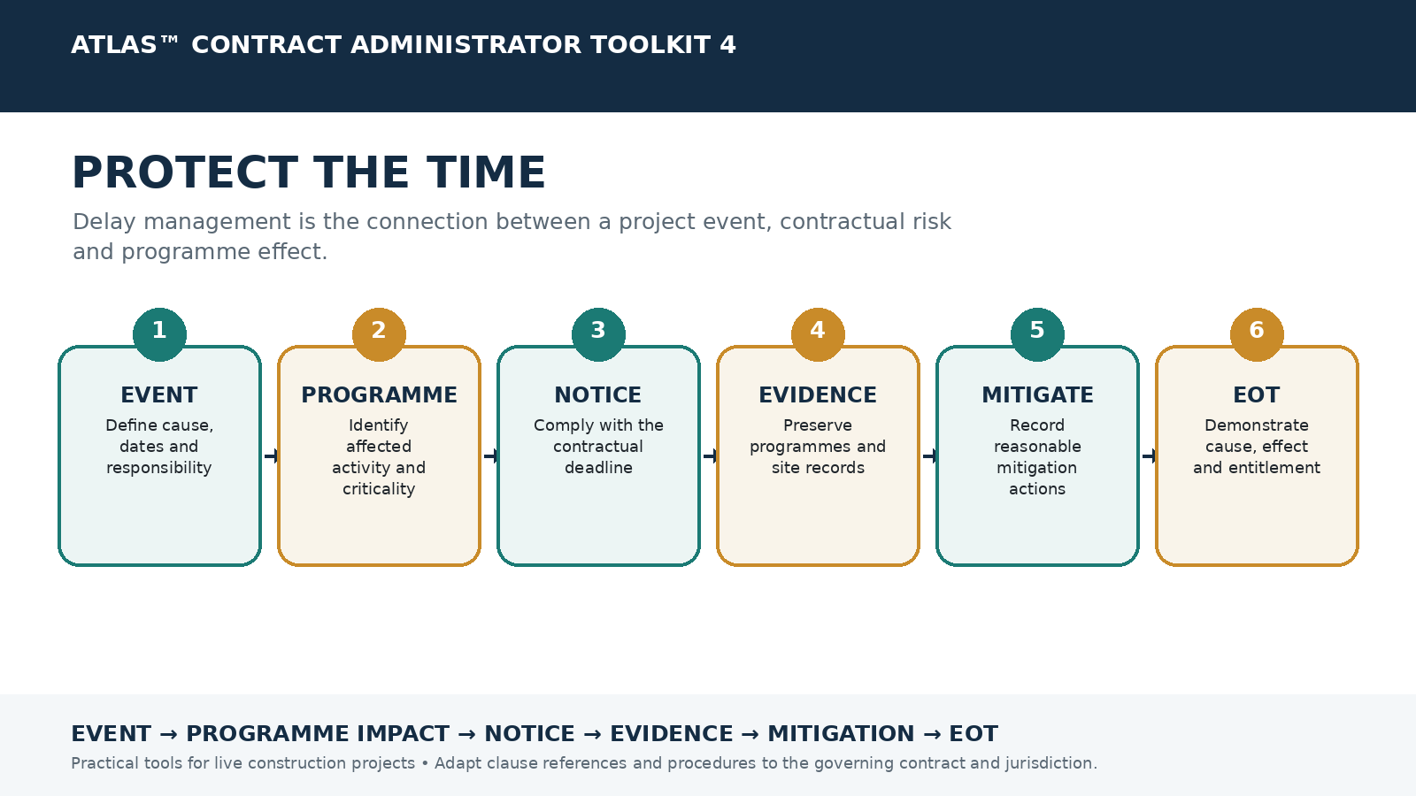

Use & Adaptation Note
This toolkit is a practical contract administration aid. It is intentionally contract-form neutral. Before use, adapt clause references, notice periods, service requirements, terminology, statutory requirements and dispute procedures to the signed contract, its amendments and the governing law. It does not replace project-specific legal advice where legal advice is required.

1. Delay Event Register
Delay Ref | Event | Start | End | Responsible Risk | Affected Activity | Critical? | Notice Ref | EOT Status

2. Delay Assessment Worksheet
Delay Ref
What happened?
When did it begin?
When did it end / is it ongoing?
Why did it happen?
Who bears the contractual risk?
Affected programme activity / WBS
Critical path impact?
Float available?
Notice clause and deadline
Notice reference
Mitigation actions
Concurrent delay issues
Estimated EOT impact
Supporting evidence location

3. EOT / Delay Notice Template
Project
Contract
Date
Notice / Letter No.
To
From

Subject: NOTICE OF DELAY AND POTENTIAL EXTENSION OF TIME
We refer to [event / instruction / circumstance] which commenced on [date].
The event is affecting or is likely to affect [activity / workfront] and may delay the Time for Completion. This notice is issued pursuant to Clause [X].
The event remains [ongoing / concluded]. Programme impact, mitigation and any concurrent effects are being assessed. Updated particulars will be provided in accordance with the Contract.
All rights to an extension of time and associated monetary entitlement, where the Contract provides for such entitlement, are reserved.
DRAFTING CONTROL Replace all bracketed fields. Verify the clause, notice period, addressee and permitted service method before issue.

4. EOT Claim Submission Structure
1. Executive summary and relief sought
2. Contractual entitlement and relevant clauses
3. Factual chronology
4. Cause of delay
5. Programme methodology and contemporaneous programme records
6. Cause-and-effect analysis
7. Critical path / completion impact
8. Mitigation undertaken
9. Concurrency analysis where applicable
10. EOT calculation
11. Supporting evidence index
12. Conclusion and requested determination

5. Delay Evidence Checklist
☐ Accepted baseline programme
☐ Updated / revised programmes
☐ Progress reports
☐ Site diaries
☐ Progress photographs
☐ Instructions
☐ RFI and drawing registers
☐ Meeting minutes
☐ Labour and plant records
☐ Procurement records
☐ Subcontractor records
☐ Access records
☐ Weather records where relevant
☐ Delay notices and acknowledgements
☐ Mitigation correspondence
☐ Acceleration instructions / requests

6. Delay Responsibility Matrix
Delay Event | Employer Risk | Contractor Risk | Neutral / Shared | Clause | Notes

7. Mitigation Log
Date | Delay Ref | Mitigation Action | Resources / Cost | Expected Benefit | Actual Result | Evidence Ref

8. Acceleration Alert Checklist
☐ Has the contractual completion date changed?
☐ Has an EOT been granted or refused?
☐ Is acceleration expressly instructed or merely requested?
☐ Is there an agreed acceleration scope and target date?
☐ Who bears additional cost?
☐ Are additional resources / shifts / resequencing required?
☐ Are productivity and cost records being kept?
☐ Is the instruction properly authorised?
GOLDEN RULE Delay is not merely an event. It must be connected to contractual risk, programme effect, causation, mitigation and the relief sought.

Implementation on a Live Project
1. Open a Delay Ref as soon as a material event is identified.
2. Issue the contractual notice before the deadline; do not wait for full impact to be known unless the contract says otherwise.
3. Ask the planner to identify the affected activity and contemporaneous critical path.
4. Preserve the programme file, update and progress records used for the analysis.
5. Maintain a mitigation log and update EOT particulars as the event develops.

Minimum Ownership
Role | Responsibility
Planner | Own programme status and time impact analysis.
Contract Administrator | Own notice, entitlement and submission compliance.
Site Team | Provide contemporaneous factual records.
Commercial | Assess monetary consequences where recoverable.
Project Manager | Approve mitigation / acceleration decisions.
IMPLEMENTATION PRINCIPLE A toolkit only adds value when someone owns it, deadlines are reviewed routinely, and project teams actually use the outputs in meetings and decisions.

ATLAS™ TOOLKIT 5
PROTECT THE MONEY
Payment, Claims & Commercial Entitlement
Link contract administration to cash flow by structuring payment and claims around entitlement, causation, valuation, evidence and recovery.

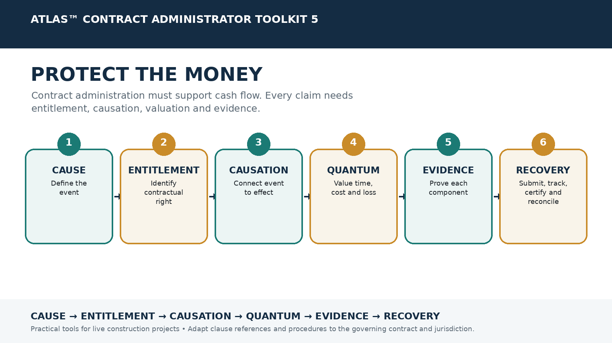

Use & Adaptation Note
This toolkit is a practical contract administration aid. It is intentionally contract-form neutral. Before use, adapt clause references, notice periods, service requirements, terminology, statutory requirements and dispute procedures to the signed contract, its amendments and the governing law. It does not replace project-specific legal advice where legal advice is required.

1. Payment Application Checklist
☐ Work completed measured and agreed where possible
☐ Variations included and cross-referenced
☐ Materials on site / off site addressed as permitted
☐ Supporting documents attached
☐ Previous certificates / payments reconciled
☐ Retention correctly calculated
☐ Advance payment recovery checked
☐ Contra charges / set-off reviewed
☐ Tax / statutory requirements checked
☐ Submission date and method compliant
☐ Payment due date diarised

2. Payment Application & Certification Tracker
Application No. | Period | Submitted | Applied Amount | Certified Amount | Due Date | Paid Date | Variance | Outstanding | Status

3. Claims Register
Claim Ref | Event | Clause | Notice Ref | Time Claimed | Amount Claimed | Submitted | Response Due | Assessed | Status

4. Claim Assessment Worksheet
Claim Ref
CAUSE – What happened?
ENTITLEMENT – Which clause / legal basis?
LIABILITY – Who bears the risk?
EFFECT – What happened to the works?
CAUSATION – How did the event cause the effect?
TIME – What extension is sought?
QUANTUM – What amount is sought?
VALUATION METHOD – Rates / cost / formula
EVIDENCE – Key records
NOTICE COMPLIANCE
MITIGATION
RELIEF SOUGHT

5. Prolongation / Loss & Expense Evidence Checklist
☐ Site staff cost
☐ Site facilities / offices
☐ Utilities
☐ Plant / equipment standing time
☐ Security
☐ Insurance / bonds extension
☐ Temporary works
☐ Supervision
☐ Subcontractor prolongation
☐ Head office overhead basis where contractually recoverable
☐ Financing / interest where recoverable
☐ Productivity / disruption records
☐ Invoices and payroll records
☐ Period attributable to compensable delay

6. Final Account Control Sheet
Component | Original Contract | Approved Change | Pending Change | Claimed | Certified / Agreed | Forecast Final | Difference

7. Payment / Certification Follow-Up Template
Project
Contract
Date
Notice / Letter No.
To
From

Subject: OUTSTANDING CERTIFICATION / PAYMENT
We refer to [Application / Certificate] No. [X] submitted / issued on [date].
Under Clause [X], the relevant certification / payment milestone falls on [date]. As at the date of this letter, [amount / certification / response] remains outstanding.
Please arrange the required contractual action and confirm the status by [date]. All rights and remedies arising from delay or non-payment are reserved.
DRAFTING CONTROL Replace all bracketed fields. Verify the clause, notice period, addressee and permitted service method before issue.

CLAIM TEST A claim must establish entitlement, causation, quantum and evidence. A time entitlement does not automatically create a money entitlement; check the actual contract.

Implementation on a Live Project
1. Create a payment calendar covering submission, certification and payment dates.
2. Reconcile every payment application against approved and pending variations.
3. Open a Claim Ref when an event may produce time or monetary entitlement.
4. Use the Claim Assessment Worksheet before submitting a major claim.
5. Keep final account control live throughout the project rather than reconstructing it at completion.

Minimum Ownership
Role | Responsibility
QS / Commercial | Own valuation, payment and quantum.
Contract Administrator | Own entitlement, notice and contractual compliance.
Planner | Provide time consequences supporting prolongation.
Finance | Reconcile receipts, overdue amounts and cash flow.
Project Manager | Escalate unresolved commercial exposure.
IMPLEMENTATION PRINCIPLE A toolkit only adds value when someone owns it, deadlines are reviewed routinely, and project teams actually use the outputs in meetings and decisions.

ATLAS™ TOOLKIT 6
PROTECT THE EVIDENCE
Records, Risk & Dispute Prevention
Create contemporaneous, organised evidence so that important project events can be proven, managed and closed long after they occur.

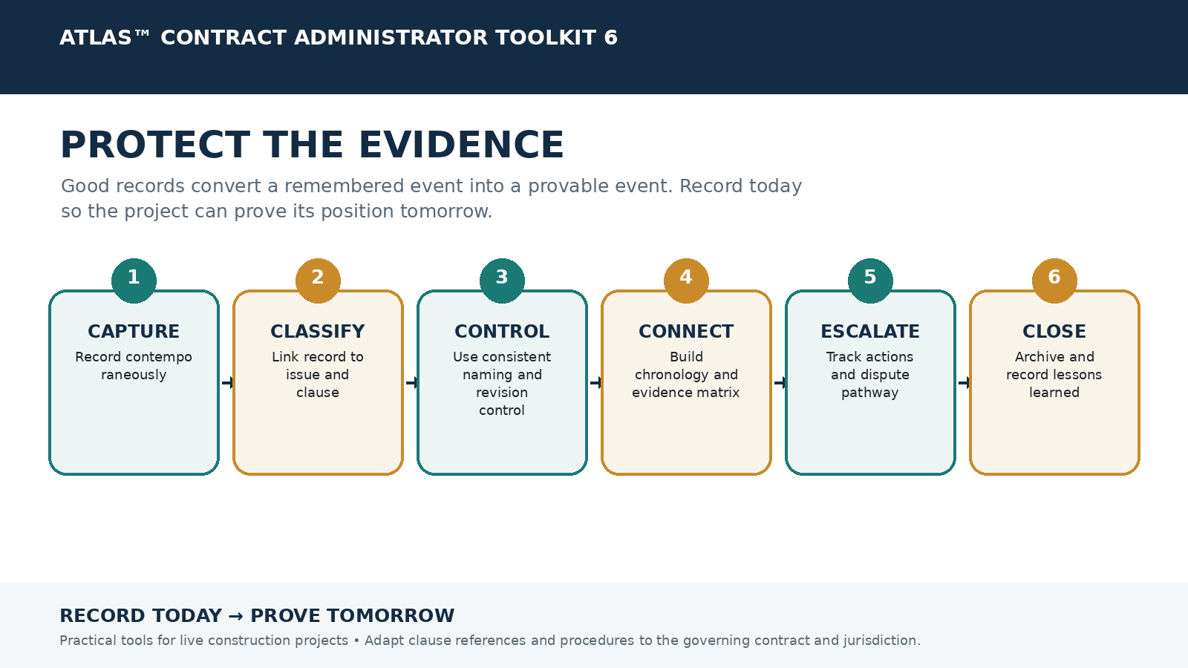

Use & Adaptation Note
This toolkit is a practical contract administration aid. It is intentionally contract-form neutral. Before use, adapt clause references, notice periods, service requirements, terminology, statutory requirements and dispute procedures to the signed contract, its amendments and the governing law. It does not replace project-specific legal advice where legal advice is required.

1. Evidence Matrix
Issue / Claim | Fact to Prove | Required Evidence | Evidence Available? | Evidence Ref / Location | Gap / Action | Owner

2. Daily Site Record
Date
Weather / Conditions
Work Areas / Fronts
Key Activities
Labour by Trade
Plant / Equipment
Deliveries
Inspections / Tests
Instructions Received
Access Restrictions
Delays / Disruption
Rework / Defects
Safety / Stoppages
Visitors / Meetings
Photograph References
Prepared By / Time

3. Photograph & Video Evidence Log
Photo Ref | Date / Time | Location | Subject / Activity | Reason / Issue | Taken By | File Location

4. Meeting Action & Decision Log
Meeting / Date | Issue | Position / Decision | Action | Owner | Due Date | Status | Evidence / Minutes Ref

5. Document Control & Evidence Protocol
- Use a unique project issue / change / delay / claim reference where possible.
- Keep original source files and preserve metadata where relevant.
- Use consistent file naming: YYYY-MM-DD – Ref – Document Type – Short Description – Revision.
- Never overwrite a superseded contractual document; retain revision history.
- Store proof of issue and receipt for formal correspondence.
- Cross-reference photographs, diaries, programmes, minutes and letters to the same issue reference.
- Restrict editing of approved / final evidence where appropriate.
- Maintain backups in the approved project document environment.

6. Contract Risk Register
Risk Ref | Risk / Issue | Clause / Contract Link | Probability | Impact | Mitigation | Owner | Review Date | Status

7. Dispute Escalation Tracker
Issue Ref | Current Level | Last Action | Next Escalation Step | Decision / Response Due | Owner | Status

8. Dispute Escalation Ladder
1. Site-level clarification and record
2. Formal contractual correspondence / notice
3. Project leadership review
4. Contractual determination / certification process
5. Senior management negotiation
6. Mediation / adjudication / dispute board where applicable
7. Arbitration or litigation where applicable

9. Project Close-Out / Lessons Learned Checklist
☐ Open notices reconciled
☐ Variations reconciled
☐ Claims status confirmed
☐ EOT position closed or clearly reserved
☐ Payment / final account status reconciled
☐ Security / retention release dates diarised
☐ Defects and completion records archived
☐ Key evidence folders indexed
☐ Disputes and reservations recorded
☐ Lessons learned captured for future projects
GOLDEN RULE If it is important, record it contemporaneously. Memory deteriorates; a properly controlled record survives.

Implementation on a Live Project
1. Agree the project evidence filing convention at mobilisation.
2. Make Daily Site Records a controlled routine, not an optional diary.
3. Use the Evidence Matrix for every significant delay, variation and claim.
4. Turn meeting minutes into tracked actions with owners and deadlines.
5. Archive project close-out evidence so future claims or audits can be reconstructed quickly.

Minimum Ownership
Role | Responsibility
Document Controller | Own controlled storage, revision and retrieval.
Site Team | Create contemporaneous factual records.
Contract Administrator | Connect records to clauses, notices and issues.
Project / Commercial Leads | Identify evidence gaps and escalation needs.
Legal / Claims Advisor | Advise where privilege or dispute protocols apply.
IMPLEMENTATION PRINCIPLE A toolkit only adds value when someone owns it, deadlines are reviewed routinely, and project teams actually use the outputs in meetings and decisions.

